- After customer login seen dashboard and press browser back button, redirect to login page
- After logout redirect to login page, now pressing browser back button, its redirecting to any cached pages.
- I can add both contact details identical
- There is no validation message for this website url 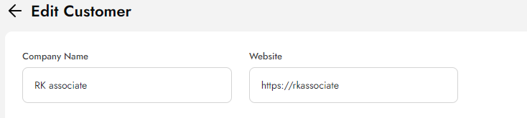
- I have logged in with customer credential and then delete customer from client admin then refresh customer panel, page break, it’s should be logout 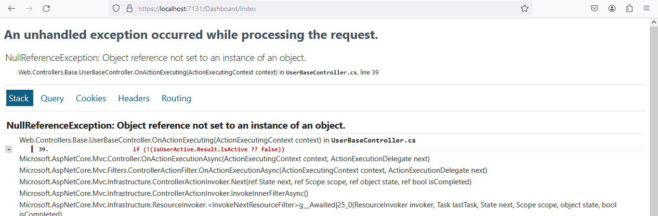
- Now press browser back button then redirecting to login page
- Now press browser next button, again 5th point error coming means user not logout
- Remove ID column from FIGMA in property listing
- Wrong placeholder also 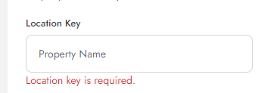
- In above label not matched with figma
- Label mismatch with figma 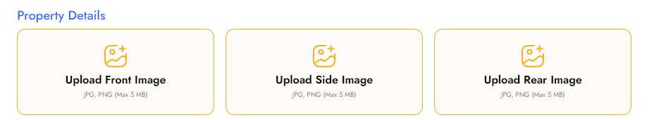
- Increase Location key length to 100
- Can we show front image validation below it, instead of toastr
- Make sure address column size will not impact on action column 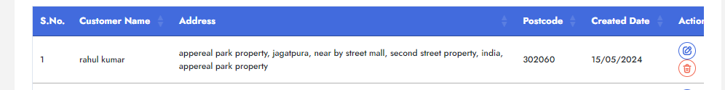
- Miss check in app side, newly created property should be come in inspector or client login in app side, if its related to them
- Some columns can not be updatable like AddedBy in SP AddUpdateCustomerDetail
- I think, Answer ordering not needed
- Method names are not correct like for property add/update there is method name AddUpdateForClient
- In that method When Add property then not needed 
- When update then not needed 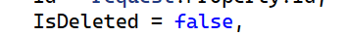
- Property folder name is in small letters on azure storage 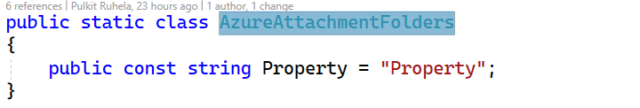
- Why changePassword method exists in Client >> Customer

